

Rocky Mountain Woodturners
A chapter of the American Association of Woodturners
December 2009 Newsletter

Contents of Newsletter

RMWT Meetings
Each month the Rocky Mountain Woodturners meet at Woodcraft of Loveland, located at 3718 Draft Horse Drive, Loveland, Colorado. We meet on the first Thursday after the first Tuesday of each month.

Meeting Format
6:00 – 6:15 – Setup and Social Time, come visit, share ideas and ask questions
6:15 – 6:45 – The general business meeting.
6:45 – 7:05 Instant Gallery and Raffle
7:05 – 7:15 Break
7:15 – 8:45 – Demonstrator time.
8:45 – 9:00 – Clean up and out by 9 pm sharp!
Scheduled Meeting
The regular meeting for December, 3, 2009, will be a Christmas Party. Details to be announced.

2009 Officers, Directors and Committees
President: Drew Nichols
970-566-4662
dcnichols2004@msn.com

VP: Katherine Kowalski
katherine@daystarhandworks.com
Phone: 307-637-2874

Treasurer: Pete Herman
Phone: (970) 663-1951, home
(585) 259-9486, mobile
Peter_herman@comcast.net

Secretary / Newsletter:
John Giem
(970) 223-0844
mailto:jgiem@comcast.net

Newsletter Team
Editor: John Giem
970-223-0844
jgiem@comcast.net
Distribution:
Kevin Dunn
970-420-9691 Cell
dnnkk@msn.com
Members:
Pete Herman

RMWT Program Director:
Trent Bosch
970.568.3299
trentbosch@yahoo.com

RMWT Librarian:
David Amos
970.834.1432
dcjeamos@juno.com

Wood Bank
Chairmen:
Allen Norris
Jerry Sherman
484-2619, home
631-2984, mobile
Wood Lot:
John Giem,
223-0844, home
227-6618, mobile

RMWT Symposium
Directors:
Mike Davis -
mailto:mikeldavisllc@msn.com
Allen Jensen
970-663-1868
Rajconst@aol.com
Registration:
John Giem
970-223-0844
mailto:jgiem@comcast.net

RMWT Webmaster
Hoyle Curtis
hoyle.curtis@gmail.com
Next RMWT Meeting, Christmas Party
RMWT Activities
RMWT Officer Elections
Treasure’s Report
EOG Announcement
Member’s web sites, sources of woodturning Instruction and discounts.

Next RMWT Meeting
The Christmas meeting will be December 3rd at Mountain Range Shadow Clubhouse, 8401 Mummy Range Dr., Fort Collins, CO. Located on the west side of I-25 about 1 mile south of the Windsor exit. Should start around 6pm. Bring your favorite dish, soft drinks and plastic utensils will be provided. Bring a Christmas ornament to be auctioned to start the Rocky Mountain Woodturners funds for the new year. Also will have a great Instant Gallery, so bring something spectacular!
Thanks,
Drew Nichols, President Rocky Mountain Woodturners

RMWT Activities
Election of RMWT Officers
At the November 5, 2009, meeting of the RMWT, the election of Officers for 2010 was held. The following were elected:
President: Katherine Kowalski
Vice President: Dave Dowding
Secretary: Allen Norris
Treasurer: Pete Herman

In addition, Allen Norris will take over the position of Newsletter Editor.

Treasurer’s Report
Beginning balance |  |  |  |  | $4,172.17
Income
Date | Source | Check/cash | Amount | Quantity | Extended
11/13/09 | Membership | check | $40.00 | 1 | $40.00
 | End sealer sale | check | $8.00 | 3 | $24.00
 | End sealer sale | cash | $8.00 | 4 | $32.00
11/5/09 | Raffle proceeds | cash | $59.00 |  | $59.00
 |  |  |  | Total income | $155.00
Expenses
Date | Source | Check/cash | Amount | Quantity | Extended
11/5/09 | Library DVDs | check | $85.50 | 1 | $85.50
11/5/09 | Monthly demo | check | $300.00 | 1 | $300.00
11/5/09 | Library DVDs | check | $65.00 | 1 | $65.00
11/23/09 | Symposium expense reimbursement | check | $88.52 | 1 | $88.52
 |  |  |  | Total expense | $539.02
Ending balance |  |  |  |  | $3,788.15

Educational Opportunity Grant
The EOG Committee is now accepting applications for grants for this year. See the following documentation for information.

Rocky Mountain Woodturners
Educational Opportunity Grant

The purpose of this document is to describe the Rocky Mountain Woodturners Educational Opportunity Grant program. Rocky Mountain Woodturners is a chapter of the American Association of Woodturners (AAW), located in Loveland, Colorado. Please visit the Rocky Mountain Woodturners (RMWT) web site at www.rmwt.org, and the AAW web site at www.woodturner.org. The RMWT meets on the first Thursday after the first Tuesday of each month at 6:30 PM at the Woodcraft Store in Loveland, Colorado.

Applications for an Educational Opportunity Grant (EOG) from the RMWT are available each year. Applicants may apply by completing the attached application form and submitting it to Rocky Mountain Woodturners.The RMWT’s would like to assist you in your woodturning education. If you have a particular goal, workshop, or project in mind and desire financial help, we would like you to apply to this program.
In order to expand and share woodturning resources, RMWT has established a fund from which grants are awarded to individuals and organizations. The grants will cover expenses such as tuition, registration, demonstrator's fees, travel, lodging, and meals.
(1) Purpose of the Program
- To allow RMWT members to benefit from their own fundraising efforts and generous support.
- To provide educational opportunities that expands and enriches the entire community.
- To provide ways that woodturning skills may be shared with RMWT members, seminars, schools, and friends.
- To allow persons outside the RMWT community to experience the benefits of woodturning.
(2) Eligibility
Applicants must be a member or sponsored by a member of the RMWT. Recipients must submit a report to the EOG committee chairperson on their experiences within three months of their completion.
(3) Grant Committee
RMWT shall establish a Grant Committee comprised of three members including a Chairperson and two others. The RMWT Board shall appoint the Chairperson. The Grant Committee Chairperson shall select two additional committee members. The Grant Committee serves at the pleasure of the RMWT Board. The board may change the committee chairperson at any time.
The Grant Committee shall perform the following duties:
1. Review applications for Educational Opportunity Grants
2. Inform the board of all EOG applications
3. Make recommendations to the board, including recommending which grants should be approved, and for what dollar amount. Three (3) Grant committee members shall vote with the Four (4) board members on grant requests. Applicants must gain five/sevenths support of the board & EOG committee in order to be approved.
4. Awards will be considered based on benefit to the applicant, to the community, to RMWT, and application concept,. Emphasis will be placed on the ability, as well as the opportunity, of an applicant to share information gained. Clarity of the application is essential, applications will be judged on the thought and the written ideas presented. Applicants will be judged on the content of the application alone.
5. The Grant Committee chairperson shall follow-up with recipients of EOGs to insure projects are completed on a timely basis, and that recipients present their results at a meeting of the RMWT, and provide a written report, which can be included in the RMWT newsletter and/or be posted on the RMWT web site.
6. The Grant Committee may recommend an EOG be awarded in unusual circumstances (relief, short-notice need, gift, etc.) without the submission of an application.
(4) Submitting an Application
All applicants must complete the Rocky Mountain Woodturners Educational Opportunity Grant Application Form and submit it to:

EOG Chairperson
Rocky Mountain Woodturners

Rocky Mountain Woodturners
Educational Opportunity Grant
Application Form

Please provide clear and concise answers to the following questions:
Name: __________________________________________________________
Date: _______________________________ Phone: _____________________
Address: ________________________________________________________
City, State, Zip Code: ______________________________________________
E-Mail Address: ___________________________________________________
Member or Sponsor name:___________________________________________
Age:_______ School affiliation:_____________________________________
1. How would you use the educational grant?

2. How would you benefit from the grant?

3. How would the community benefit from your grant?

4. Please give an itemized budget of how you intend to use the grant.

TIPS ON USING THIS FORM:

- Type, print or write legibly, your answers to the questions.
(If you download a copy from the RMWT website, you can download it in MSWord and type your answers right on the form, print and mail it to the RMWT.)

- Please do not submit CD’s or notebooks full of supporting data or photos. The grants are rated by the content of the answers to the questions. They are considered on their own merit.

- Please answer the questions in a clear and concise manner. Include additional sheets, if necessary.

- Please provide the name that will appear on any award check

- Budget: It is OK for your budget to exceed the award amount.

- Applicants may apply for a grant to:
  - Attend a symposium, workshop, or school.
  - Enable a special project.
  - Cover teaching expenses.
  - Any other reasonable cause

Submit 2009 completed applications to EOG Chairman John Harpold by e-mail to jmharpold@skybeam.com or US mail to 6203 County Road 29C, Bellvue CO 80512. If you have questions regarding RMWT EOG grants, please contact John Harpold at the above addresses or by phone at (970) 482-0439, or anyone else on the EOG committee or RMWT Board.

The deadline for 2009 EOG grant applications is January 15, 2010

Equipment for Sale
Monty Weymouth has a Delta Milwaukee Lathe for sale. It has a 46" bed and 12" swing. He is including some turning tools and is asking $250. He will be glad
to help deliver it. Monty can be reached at 970 416-6590 or 970 222-8525.
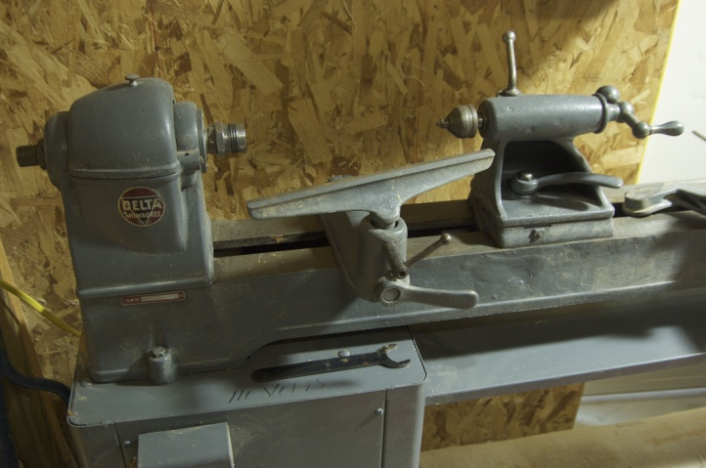
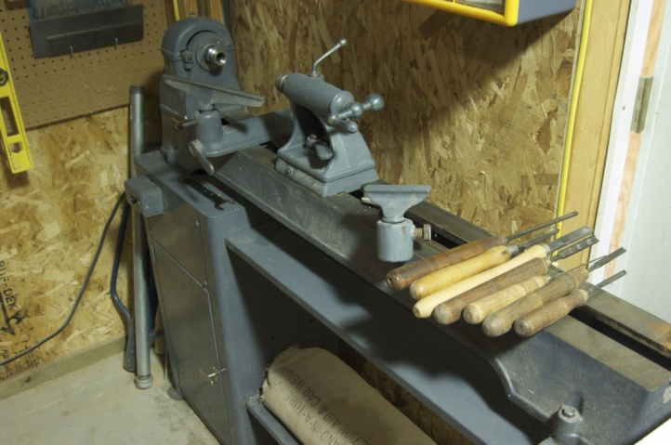

10% Guild discount
Wood Emporium
618 N Garfield Ave Loveland,

Sears Trostel
1500 Riverside Ave
Ft. Collins, CO 80524

Rockler’s in Denver – You have to show your membership card.

Woodcraft
3718 Draft Horse Drive
Loveland, CO 80538
970-292-5940
Discounts on day of Club Meeting.
Clubs and Member’s Websites

Rocky Mountain Wood Turners
www.rmwt.org

AAW – American Assoc of Woodturners
www.woodturner.org

Trent Bosch
www.trentbosch.com

David Nittmann
www.davidnittmann.com

Cindy Drozda
www.cindydrozda.com

John Lynch
www.johnlynchwoodworking.com

Curt Theobald
www.curttheobald.com

Katherine Kowalski
http://www.DaystarHandworks.com

Want your Website Listed? Contact a member of the Newsletter Team!!!

Learn From the Best…
Our Club, RMWT, is known around the nation because we have some of the best turners, nationally known demonstrators and best teachers of Basic Turning, Intermediate, and Advanced and Specialty turning right here in our own back yard.

Trent Bosch Woodturning Workshops
Workshops are held in Trent’s studio in Fort Collins, Colorado. There is a maximum of four people in each class, which allows for lots of individualized instruction. The cost is $500 for the 3-day intensive workshop and $650 for the 4-day. Meals are also provided at no extra charge. His studio is also equipped with the highest quality equipment available for your use. For detailed information on workshops visit www.trentbosch.com or contact Trent via email or phone.

Trent Bosch
Trent Bosch Studios Inc.
trent@trentbosch.com
970 568 3299

Lee Carter operates the Rocky Mountain School of Woodturning in LaPorte, Colorado. He offers classes in Basics, Intermediate and Advanced. Lee also offers private tutoring. Seven different brands of lathes are available.
Call Lee Carter at 970-221-4382 to sign up or have him answer any questions.
e-mail LLJTC4X4149@ CS.COM

Curt Theobald offers three-day workshops in Segmented Woodturning in his studio in Pine Bluffs, Wyoming.
Call Curt Theobald at 307.245.3310
E-mail cwtheobald@wyoming.com
Website is www.curttheobald.com

John Giem, Woodworker
Individual or small group woodworking instruction customized to the needs of the student. Offering both woodworking on the lathe and combined with regular power tools. Classes are held in John's workshop in Fort Collins, CO, which is equipped with a complete set of woodworking tools. Contact John to discuss your interests and needs.
jgiem@comcast.net
(970)223-0844, home phone
(970)227-6618, cell phone
____________________________________________________________________________

Woodcraft has classes for beginners in woodworking, shop safety, intro the machines, bowl turning, pen and pencil turning, hollow forms, Christmas tree ornaments, tool sharpening, etc. Please check out the class being offered at web page

www.woodcraft.com/stores/store.aspx?id=56

